Technical Project Team

Join Workstations to Domain and Migrate User Roaming Profile to OneDrive
Standard Operating Procedure

PREPARED BY
Kelvin Aruin – Senior Technical Project Engineer

Preparation – Locate Info on Domain Controller
- Log in to the Primary Domain Controller and open Active Directory Users and Computers.
- Locate the user account you will be migrating to and open the user account properties, then select the Profile tab.
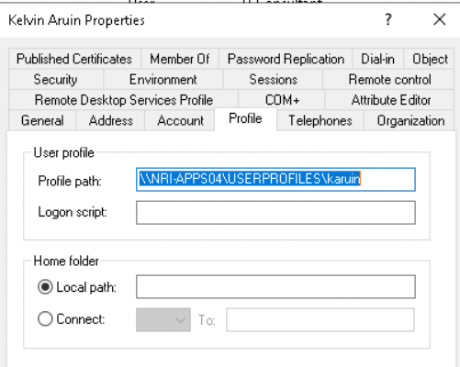
- Locate the “Profile path” field and copy the URL to notepad or OneNote to be used later.
Prepare Workstation
- Log in to user workstation as a local administrator
- Create a new temporary directory such as C:\TEMP\UserProfileTemp\
- Open the run box by pressing the Windows key + R key together.
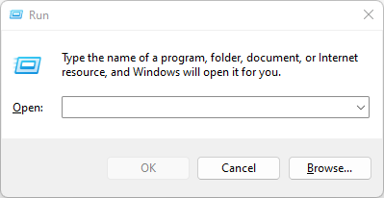
- Paste the path into the run box omit the username and press the OK button.
  - If the path is \\servername\userprofiles\JOHNDOEUSER\, you will want to use only the \\servername\userprofiles\ part of the directory string and paste it into the Run box.
- Locate the JOHNDOEUSER directory in the Windows Explorer window that opens and copy the directory to the workstation C:\TEMP\UserProfileTemp\ directory.
- The roaming profile is now saved locally on this workstation and should be located inside the C:\TEMP\UserProfileTemp\JOHNDOEUSER\ directory.
Join Workstation to Domain
- Log in to the workstation as a local administrator.
- Press the Windows key + R key together to open the Run box.
- Type sysdm.cpl into the run box and press OK.

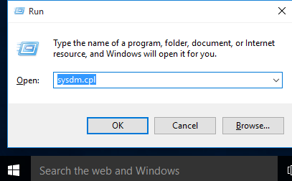

- The System Properties box will open.
- Under System Properties, select the Computer Name tab and click Change.

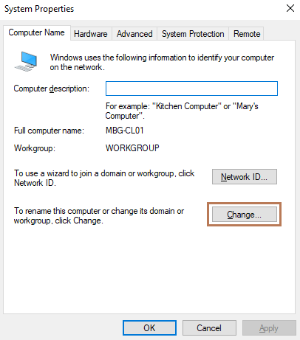

- In the Computer Name/Domain Changes dialog box, choose Domain under the Member of option and enter the domain name of your AD Domain and click OK.
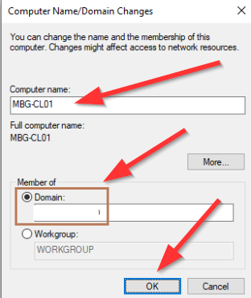
- Restart the workstation as prompted.
- The workstation should now be in the domain.
Remove the Roaming Profile from User Account
- Log back onto the domain controller.
- Open Active Directory Users and Computers.
- Locate the user account in Active Directory.
- Open the user account properties and remove the path from the Profile path field under the User profile heading.

- Press Apply.
- Press OK.

Setup Domain User on Domain-Joined Workstation
- Log in to the workstation with the user domain user account (DOMAIN\JOHNDOEUSER is what we used as an example in this document).
- Once you are logged in with the above user account, log off.
- Now log back in with the domain administrator account.
- Open Windows Explorer and browse to the C:\Users\JOHNDOEUSER.DOMAIN\ directory and leave it open. This directory was created when you first logged into the domain with the domain account.
- Open another Windows Explorer window and browse to the C:\TEMP\UserProfileTemp\JOHNDOEUSER\ directory.
- Select all files and folders in the user backup directory and paste them over all the files and folders in the C:\Users\JOHNDOEUSER.DOMAIN\ directory. Answer yes or allow any prompts that come up.
- Alternatively, you may use robocopy to copy the data by utilizing the following string in the command prompt:
  - Syntax: Robocopy “SOURCE” “DESTINATION” /MIR /MT:16 /Z /W:5 /V
  - Example: robocopy “C:\TEMP\UserProfileTemp\JOHNDOEUSER\” “C:\Users\JOHNDOEUSER.DOMAIN\” /MIR /MT:16 /Z /W:5 /V
- Restart the workstation.
- Login with the JOHNDOEUSER domain account.
- All user roaming profile settings should now be stored on the local machine rather than on a remote server share.

Setup OneDrive on Domain User Profile
- Open OneDrive from the link in the Start Menu.
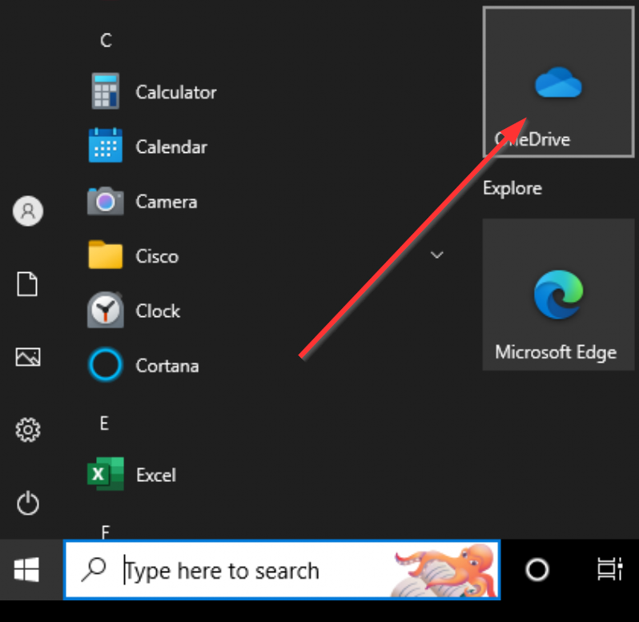
- Set up OneDrive on the workstation utilizing the user O365 credentials and make sure that the user profile directory is synced to OneDrive, then press Sign In.
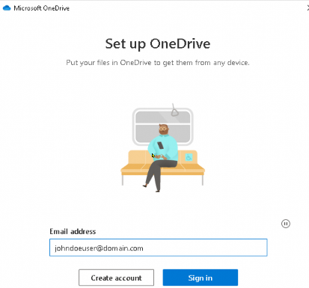
- If prompted to select Personal or Work or School, click on Work or school.
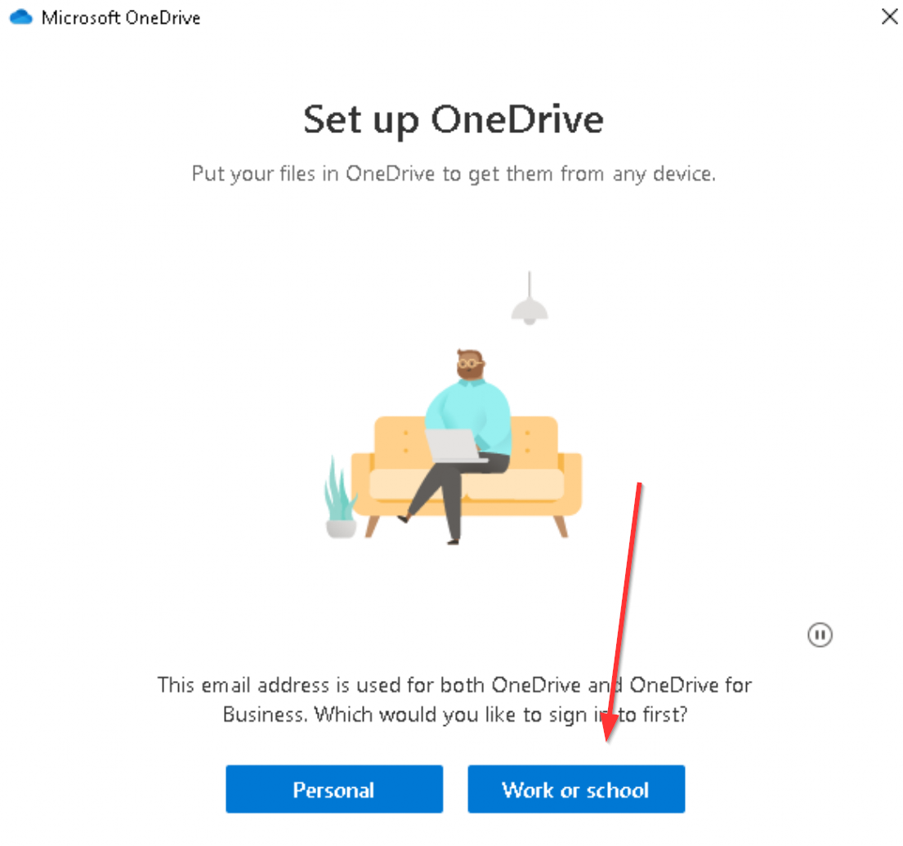

- Follow the prompts and make sure the C:\Users\JOHNDOEUSER.DOMAIN\ directory is included in the OneDrive sync.
- That’s all folks!

